Confirmations from NYSERDA of CEC Community Campaign Completion:
Community Solar:
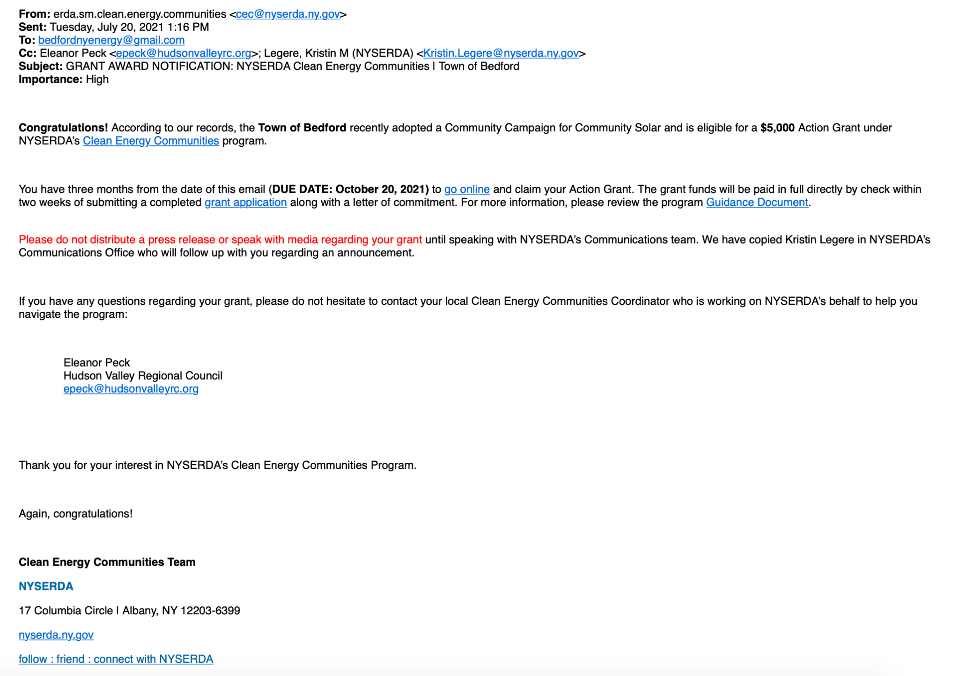

Demand Response:

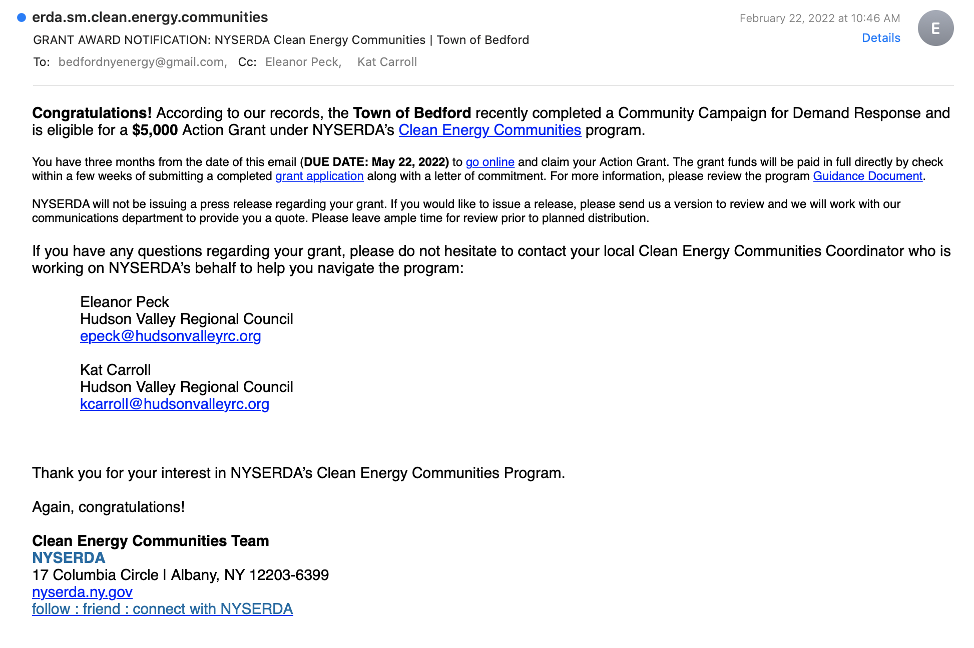

Clean Heating and Cooling:

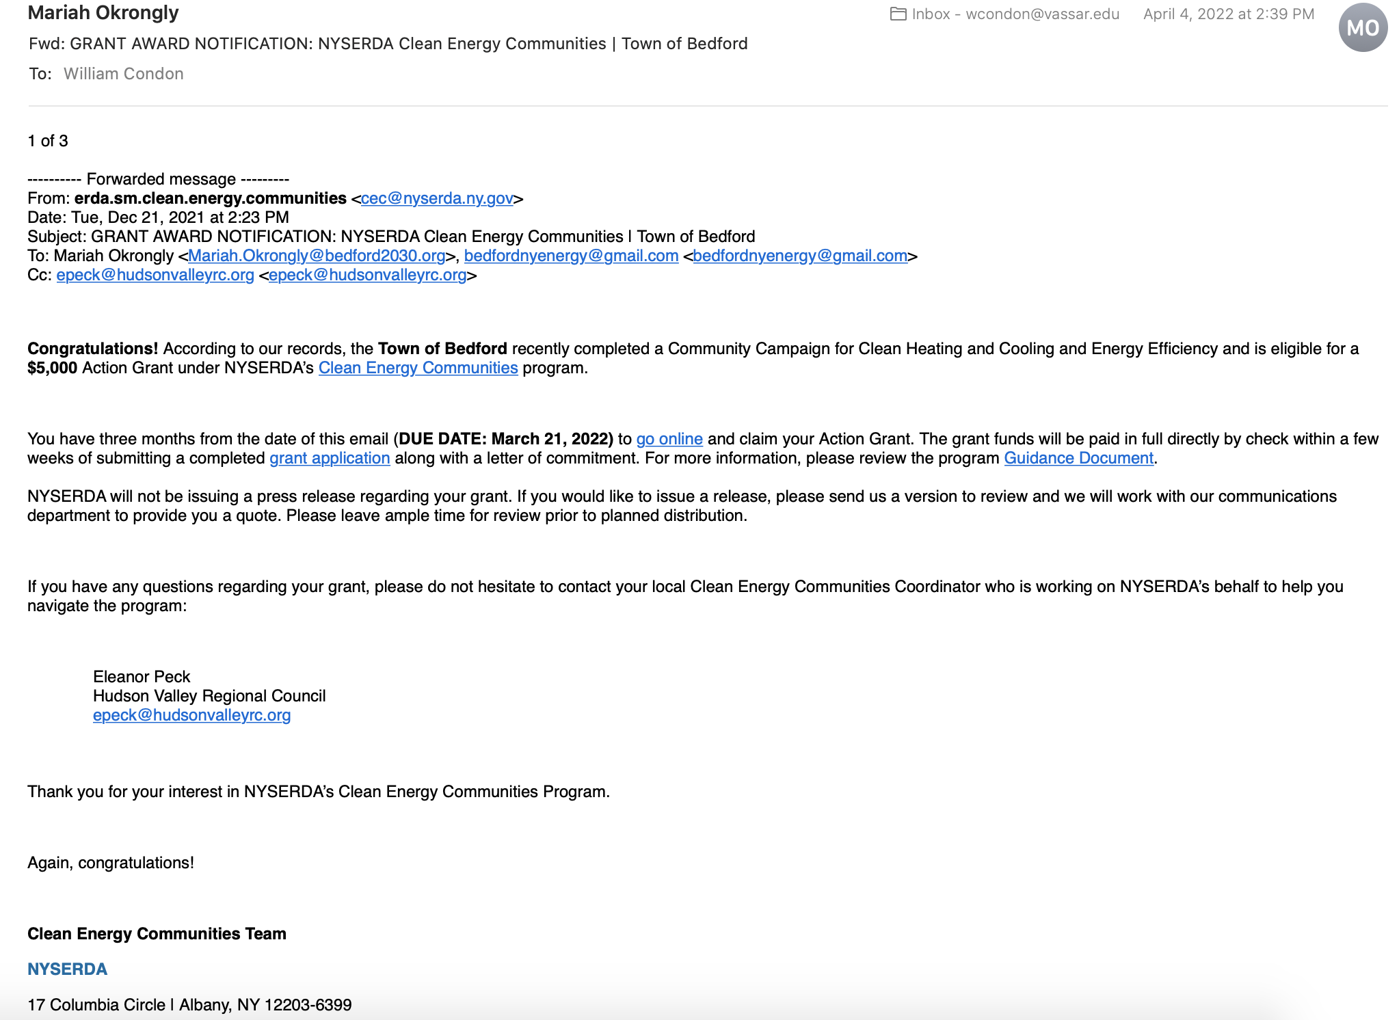

Electric Vehicles
Our EV Campaign started February 15, 2022 and we received confirmation that it was approved on 8/9/22.
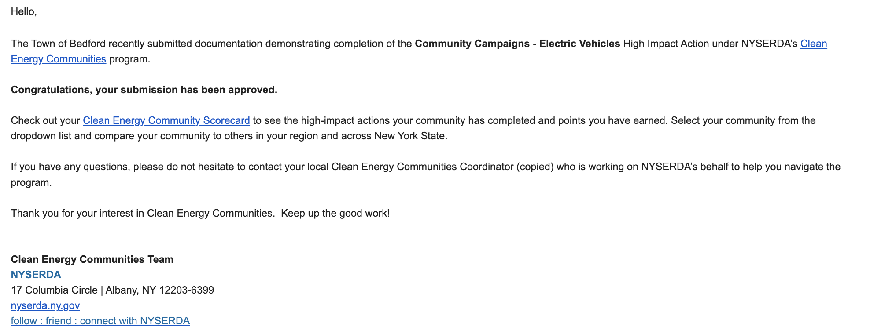

Dates:
