PE4 Action: Heat Pumps July 2, 2021

Erie County has completed installation of 4 heat pumps at 4 of our municipal facilities; Wendt Beach, Emery Fieldhouse, Como Lake Lancaster House and Grover Cleveland Pro Shop. These units were installed between November 2020 – January 2021. (19 pts)

This is an example of the sign that was hung after completion:
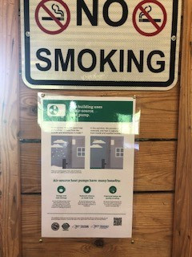

Uploaded along with this will be the proposal, purchase order and invoice for the heat pumps.

Erie County has received approval from NYSERDA that indicates completion of the Clean Energy Communities Clean Heating and Cooling Demo high-impact action. That approval will be uploaded to the portal. (3pts)

