PE7 Action: Culverts & Dams July 1, 2021

Conduct an assessment of all road-stream crossings that fall under the responsibility of the local government using the NAACC protocol | 2
Erie County is working with the Soil & Water Conservation District, which in 2017 started a road-stream crossings inventory process using the NACC protocol. To date, 153 culverts have been assessed. These not only include county culverts but also municipal and private culverts, as it is important that all work cooperatively in order to make an impact. Due to the fact that we have so many total culverts we have started work in the upper reaches of our most prime trout habitat waters and are slowly working our way outward. See attached final report and database.

Develop a road-stream crossing municipal management plan that prioritizes crossings for replacement based on threats to flooding and aquatic connectivity | 2

Erie County uses the area flood studies that NYSDEC has completed to prioritize and manage the replacement of road-stream crossings, as the studies include climate resiliency and ice jam flooding. A copy of one attached. NYSDEC has completed a number of these studies, which cover almost all of Erie County.

Right-size at least one culvert or bridge. It must not be a barrier to aquatic connectivity and must be sized to future climate projections (e.g., to the standards recommended in the Draft NYS Flood Risk Management Guidance). A maximum of 12 points is available for 2 (or more) right-sizing projects | 12
Erie County Department of Public Works worked with the Soil & Water Conservation District, qualified engineers, and the NYS Department of Environmental Conservation (DEC) staff to replace and right-size a number of culverts. This work includes two projects in 2017 on Eastwood Road, one project in 2018 on Williston Road, three projects in 2019 (one on Genesee Road and two on Pavement Road), and one project in 2020 on Cedar Street.

Attached is documentation for three of these projects: Eastwood Road, & Genesee Road descriptions and after pictures are below.

Eastwood Road culvert project was completed because a beaver set up shop in the 48” corrugated metal pipe (CMP) culvert. That created a lake on the upstream side and eventually a storm event overtopped the road and washed it out. We replaced the 48” with a 72” right sized culvert. The picture page is prior to construction but after the storm event. The single picture is after construction.
Genesee Road culvert is a tributary to Spooner Creek. The culvert had separated in the middle and caused a large sink hole to form after a significant storm event plugged up the inlet and overtopped and flooded the road and adjacent landowner’s house. A complete resizing and replacement was necessary. 48” CMP culvert to a 60” High Density Polyethylene (HDPE) culvert. Construction pictures of inlet and outlet of new culvert are attached.
Eastwood Road Culvert after picture 2017

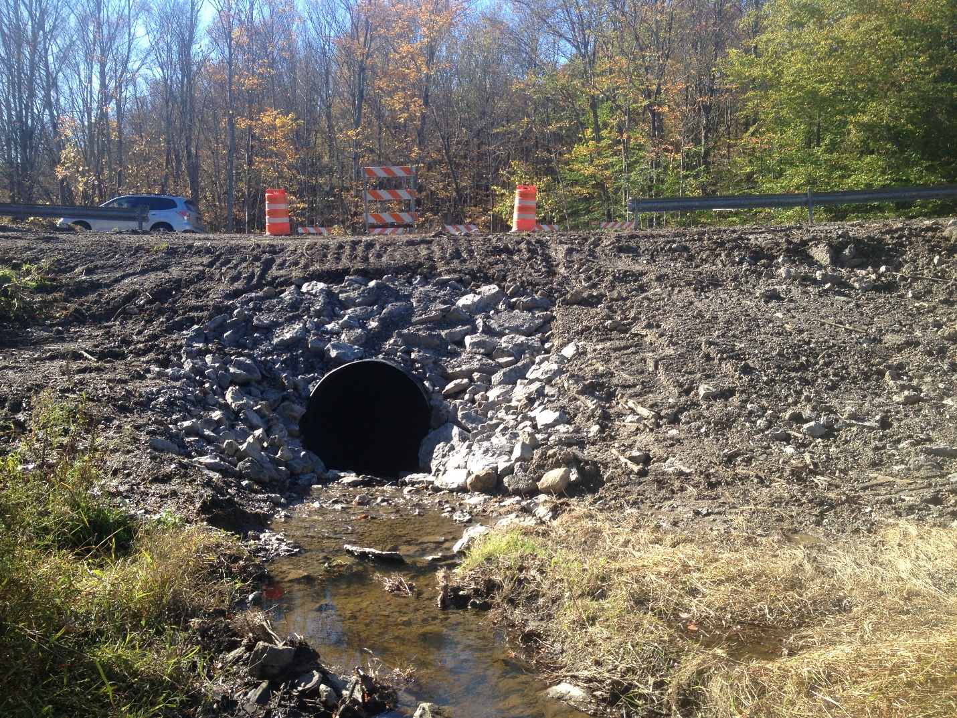

Genesee Road Culvert after picture 2019

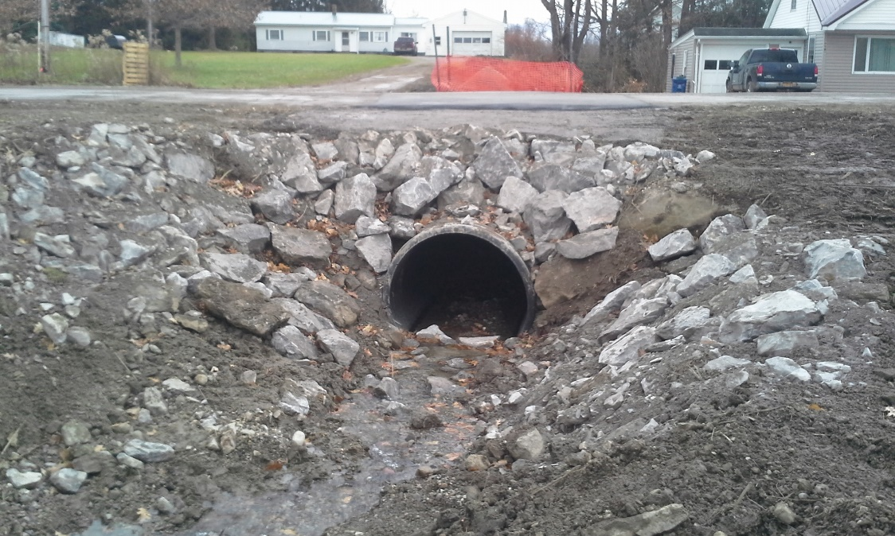

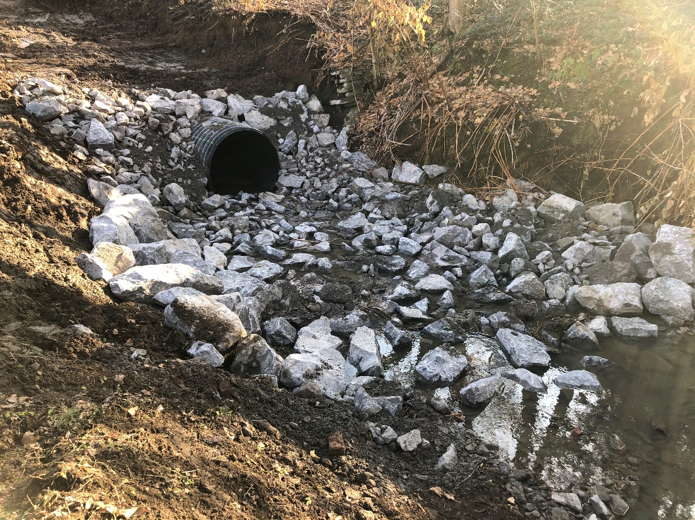

Conduct a dam inventory | 2

Erie County’s completed Dam Inventory is attached. We are currently working with partners on a dam removal.

