PE8 Action: PACE Financing July 2, 2021

Erie County adopted a PACE local law in February 2019, just as it was changing to Open C-PACE, and as a result an MOU was never signed. Erie County adopted the Open C-PACE local law in 2021 Erie County Local Law Filing and the paperwork to complete the MOU, which was delayed due to the pandemic, has been submitted and finalized. Erie County is looking forward to working with our partners at EnergizeNY, NYSERDA’s Clean Energy Community program, the WNY Sustainable Business Roundtable and the Erie County Industrial Development Agency to promote PACE. A workshop is currently being planned.
Erie County is listed on the Municipalities in New York State with an OPEN C-PACE Program website as a participating municipality. EIC PACE Muni Below is a screenshot of this:
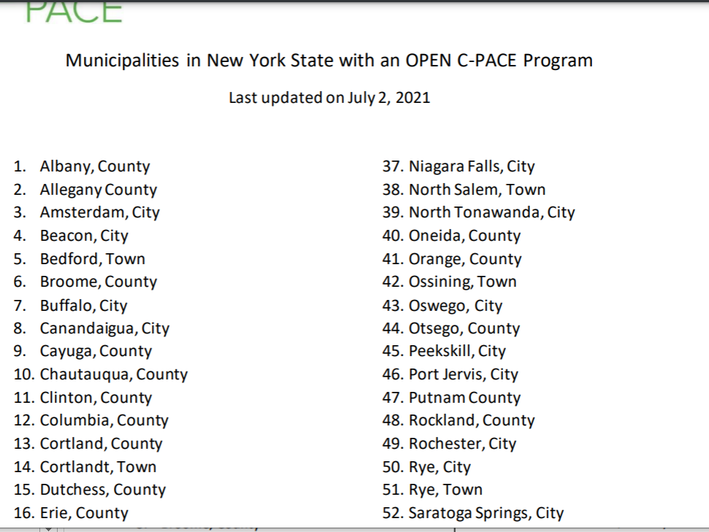

Uploaded to the portal will also be the letter of certification from Jason Kulaszewski, Clean Energy Coordinator who is NYSERDA’s contracted Clean Energy Communities Coordinator for Erie and Niagara Counties.

