# **PE7 Action: Cooling Centers** June 30, 2021

The Erie County Department of Health (ECDOH) issued this press release on 7/06/2020 to advise the public on its cooling centers that were active in the County and that also adhered to NYS COVID-19 restrictions. That press release can be found here: [ECDOH URGES PRECAUTIONS DURING EXTREME HEAT](https://climatesmart.ny.gov/actions-certification/actions/?type=1336777436&tx_sjcert_action%5BactionObject%5D=93&tx_sjcert_action%5Baction%5D=getPDF&tx_sjcert_action%5Bcontroller%5D=Action&cHash=54dc4b5848ffd02521ba673283775c45).

The ECDOH also advised the public on its social media account as well [ECDOH Facebook post](https://www.facebook.com/ecdoh/photos/a.546724125386514/3385159698209595/?type=3)

Here are some screenshots of the information:

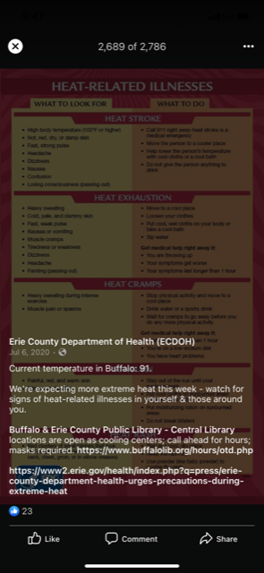 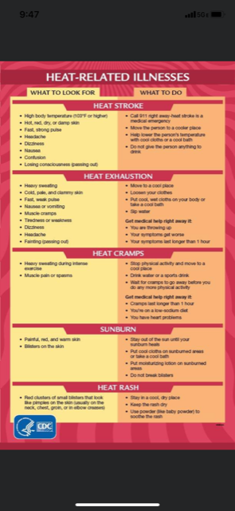

Below is a tweet from ECDOH in 2019:

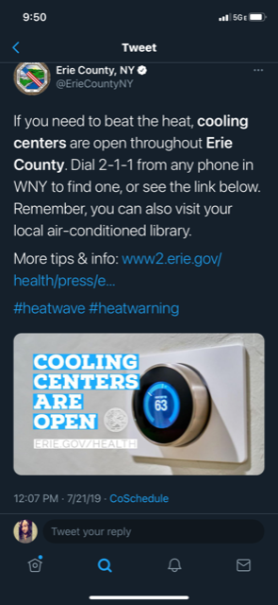

Local media covered the press release issued by ECDOH: [WGRZ Buffalo and Erie County public libraries open as cooling centers](https://secure-web.cisco.com/1vaiOL1qTZYvaFMi6nobTquNKb66B_LfcMqDUgRHMW6XTfv0idrUKuX1A6-13UxHrxFRZO1eUccaVNonfBmatjvHrrmbW_-5eB7fZeFhp9r1trtrQLqkcWZy_EIcGnT4rbOsisDjY0Zs-5FQkXXUfhunIIVuRXSZPhUMbIqn_Cnza8S8nsU_muk3ZSWPMiP2Ns03kj-hpWMQdVgF5lNcaHI_lL9BgEkUeivLaqF1ROq3IpESBjvIyRqALVomnSWEOa16QEGw8T0f_Nsz4G1CgmFEKO4RAB_gCsk6Rfgd6XtOU9ipQdgwm1dvm2BQXsOof/https%3A%2F%2Fwww.wgrz.com%2Farticle%2Fnews%2Fhealth%2Fbuffalo-and-erie-county-public-libraries-open-as-cooling-centers%2F71-e015fb22-e586-4cb2-99a6-fbc8f0492b98)