PE3: Green Building Certification
Gateway Center (WCC):
https://www.sunywcc.edu/about/about-the-college/sustainability-projects-initiatives/westchester-community-college-green-initiatives/#gateway
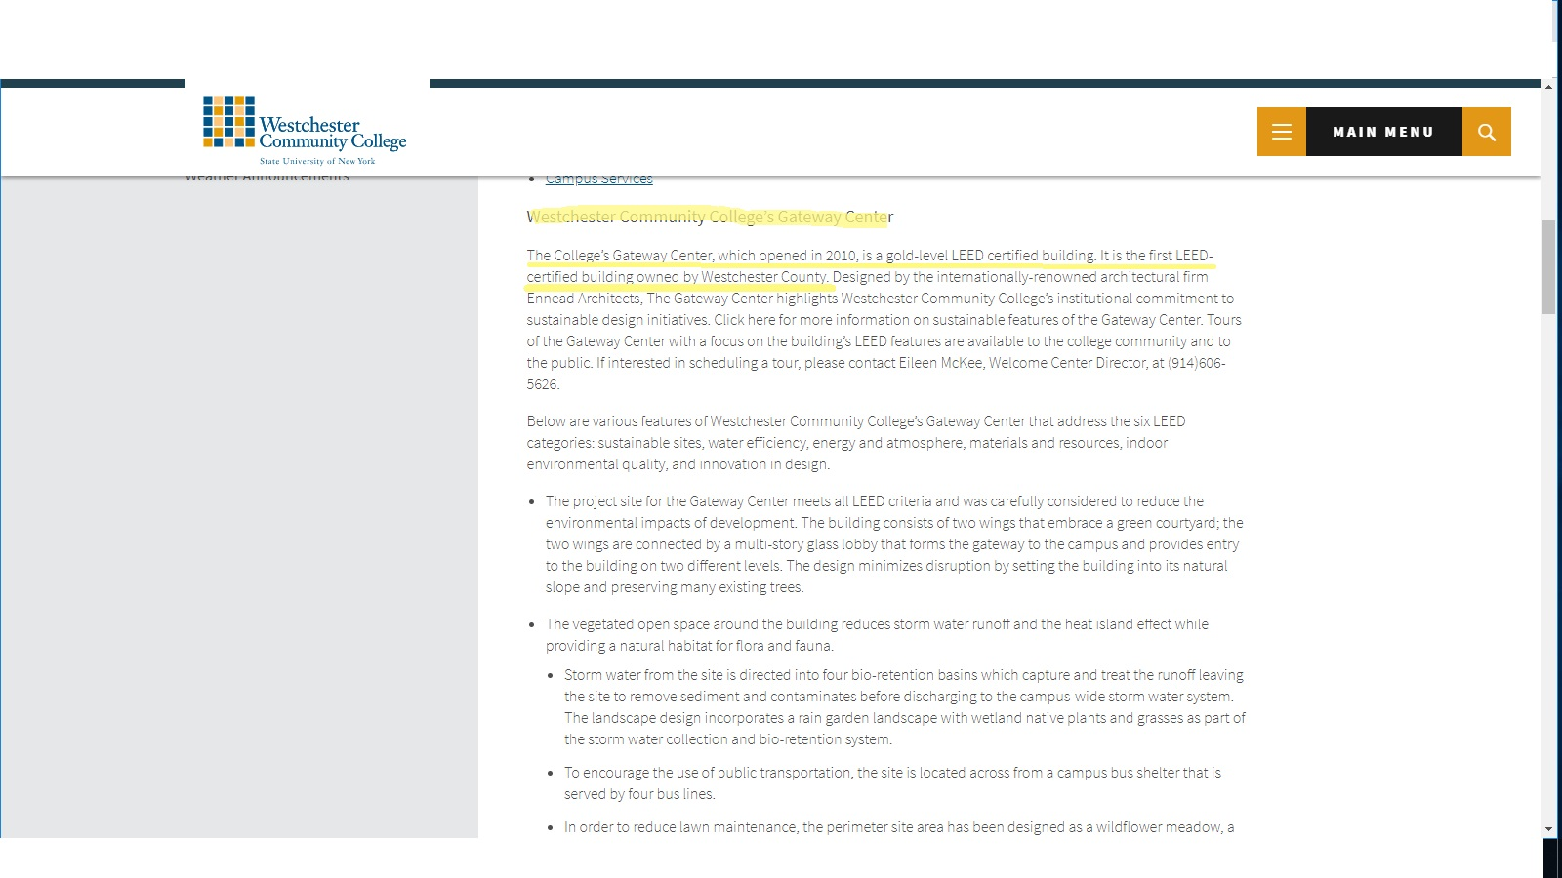
Here is a hyperlink and a screenshot to the official WCC website, announcing that the Gateway Center is LEED gold certified, it was constructed in 2010, and it is owned by Westchester County.

