PE5: Waste Reduction Education Campaign

Westchester County has spearheaded a waste education campaign called “Recycle Right.” It focuses on educating residents about what materials are allowed to be recycled by the County, the correct way to prepare the materials before recycling them, and how to separate recyclable materials appropriately. It started in early 2019 and is an ongoing initiative, aimed at reaching all residents of Westchester.

Several YouTube videos have been produced by the County’s Department of Environmental Facilities in conjunction with the Recycle Right campaign to visually explain the proper way to recycle. Here are the links to the videos, all produced between March and April, 2019:

https://www.youtube.com/watch?v=XIq3c1GcRes (Episode 1)
https://www.youtube.com/watch?v=6TUa-Ukco0s (Episode 2)
https://www.youtube.com/watch?v=3gP5eawO29I (Episode 3)
https://www.youtube.com/watch?v=33XCWy4Uq6U (Episode 4)

In addition, the County organized a press release about the campaign, as well as a flyer, that was posted on the County’s social media pages and was distributed at various public events, including the Clearwater Festival in Croton-on-Hudson on June 15-16, 2019. The attendance at this event was about 5,000 people on Saturday and about 3,500 on Sunday.

A copy of the flyer has been uploaded as supporting documentation.

Here is the website announcement about the Recycle Right campaign, which was published on April 1, 2019:
https://www3.westchestergov.com/home/all-press-releases/7963-westchester-launches-recycle-right-campaign-the-county-s-refuse-district-continues-to-recycle-everything-left-at-the-curb-as-recycling-programs-throughout-the-u-s-are-suspended
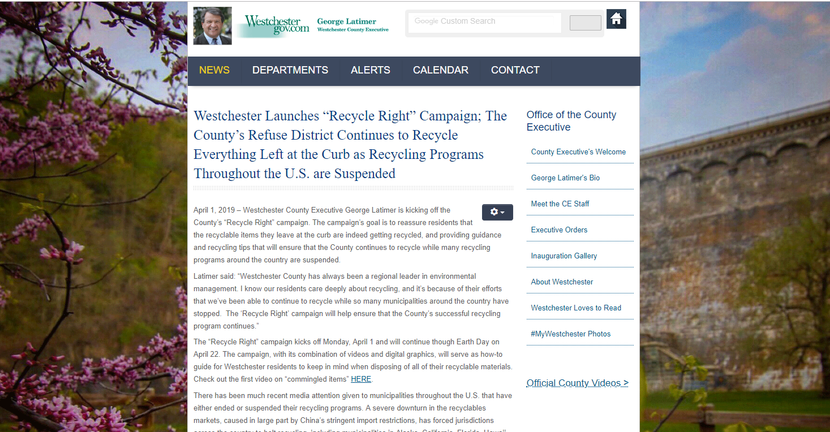
Text from the press release:
Westchester County Executive George Latimer is kicking off the County’s “Recycle Right” campaign. The campaign’s goal is to reassure residents that the recyclable items they leave at the curb are indeed getting recycled, and providing guidance and recycling tips that will ensure that the County continues to recycle while many recycling programs around the country are suspended.
Latimer said: “Westchester County has always been a regional leader in environmental management. I know our residents care deeply about recycling, and it’s because of their efforts that we’ve been able to continue to recycle while so many municipalities around the country have stopped. The ‘Recycle Right’ campaign will help ensure that the County’s successful recycling program continues.”
The “Recycle Right” campaign kicks off Monday, April 1 and will continue though Earth Day on April 22. The campaign, with its combination of videos and digital graphics, will serve as how-to guide for Westchester residents to keep in mind when disposing of all of their recyclable materials. Check out the first video on “commingled items” HERE.
There has been much recent media attention given to municipalities throughout the U.S. that have either ended or suspended their recycling programs. A severe downturn in the recyclables markets, caused in large part by China’s stringent import restrictions, has forced jurisdictions across the country to halt recycling, including municipalities in Alaska, California, Florida, Hawaii, Idaho, Ohio, Oregon, Washington, and even one in Upstate New York. Philadelphia and Memphis have reportedly scaled back recycling programs due to the market disruption. However, amid all the market chaos, Westchester County’s Refuse Disposal District has continued to market all of its residents’ recyclables to recyclables brokers and re-manufacturers.
Deputy Commissioner of the Department of Environmental Facilities Louis Vetrone said: “For years, we’ve placed the emphasis on recycling more, but now it’s important that we recycle right. That means including only those items that are recyclable in the recycling bins. It also means cleaning recyclables to reduce contamination, and keeping them loose for collection, never packaging them in plastic bags.”
Historically, China has been the largest importer of recyclable material. In late 2017, China enacted certain provisions of its National Sword policy, which banned the import of certain recyclables and placed contamination limits on other imported recyclables that are so difficult to meet that they in essence operate as a ban. China’s goal is to develop a system that taps into the country’s own recyclables generated by its 1.4 billion residents. Other countries tried to fill the void left by China’s departure from the market, notably India, Vietnam and Thailand, but now they are imposing their own contamination restrictions. The result has been a worldwide recession in the recyclables market. Westchester County has been able to weather the storm because it markets very clean, high grade recyclables.
Westchester County Director of Energy and Sustainability Peter McCartt said: “In Westchester, we are immensely proud of our efforts on recycling – and this new campaign will only serve to bolster them. Westchester residents can rest assured, while other programs may be shuttering, we are working hard to keep ours thriving.”
Westchester operates Refuse Disposal District No. 1, comprised of 36 of the County’s 43 municipalities and including about 90% of the County’s population. The District operates a dual-stream recycling program, which requires residents to separate pulp recyclables (paper and cardboard) and commingled recyclables (glass, plastics and metals). Many jurisdictions throughout New York and the rest of the nation operate single-stream recycling programs, where residents place all of their recycling into one container. Dual-stream programs produce cleaner recyclables than single-stream. In single-stream programs, the glass breaks and shards get embedded in the paper and cardboard reducing the value of those items. Also, residual liquid in beverage containers contaminates the pulp recyclables.
Westchester processes the District’s curbside recyclables at the Material Recovery Facility (MRF) in Yonkers, NY. The County’s MRF was retrofitted in 2012 with state-of-the-art optical sorters. Automated paper screeners were added a couple of years ago. The equipment upgrades are efficient at removing contamination and help create a clean product for marketing.
The County is preparing web-based and print materials based on the new Recycle Right program. These easy-to-follow guides explain which recyclables belong in each bin and provide information on how to clean the materials and leave them curbside. For instance, recyclables should never be placed in plastic bags for collection. Not only do the plastic bags contaminate the recyclables, they can potentially damage the sorting equipment at the MRF. The Recycle Right materials will be shared with all of the municipalities in the Refuse District to assist in getting the word out to residents.

Here is an example of the social media posts about the Recycle Right Campaign:

This specific post was made on the Westchester County Department of Energy Conservation and Sustainability Facebook page. (https://www.facebook.com/WestchesterSustainability/?eid=ARCJqbWZPiqT7aTpG3kIfoCZ-QHfY3TGiyuMRLi3k8UXOAq23a2LautivMkpU8K19XC4zeYehYuFimbK)

