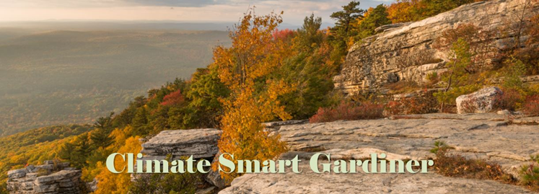
Minutes of the March 4, 2020 Meeting
Gardiner Town Hall

Task Force Members Present: Jason Mayer, Kim Mayer, Holly Shader, Rebecca Carucci, Franco Carucci, Aimee Spring-Cecil and Stephen Weir, Recording Sect.
Task Force Members Excused. Suger Rowinski, Mark Varian and Rick Irizari.
Guests In Attendance: Tara Hoey, Riley Brutvan, Melinda Beuf, Yancey Stanforth-Miglore, Meadow and Briana Carlini.
Opening: Jason opened the meeting. The prior meeting minutes were reviewed and approved.
- CCA: Jason mentioned that the County had held another CCA meeting attended by Mark. They continue to push for community and county-based energy generated within a town’s/county’s infrastructure. The next meeting will be held on 3/23 in Kingston. Our public hearing is 3/10 @ 7 p.m. in Town Hall. Everyone is encouraged to come and support Franco.
- Natural Resources Inventory – Due to a confusion generated by the EEC as to the location of the meeting, no one attended. They intend to re-schedule.
- Repair Cafe – Was held on 2/23 in the Library. Attendance was good.
- Plant Based Diets – Will be presented by Rebecca on March 7th at the Library. She will advocate switching to a plant-based diet to reduce global GHG emissions.
Recurring Business:
- Green Expo. Aimee briefed that the Expo is ready for 3/21. A total of 18 vendors are expected to attend. Volunteers are asked to show up at 10:15. Publicity has been sent to the Daily Freeman, New Paltz Times, Woodstock Radio and the Gardiner Almanac. Please spread the news on social media. Aimee indicated that there will be a Town Blast and the Town Board will announce it.
- CCA: Franco indicated that he had reached out to Pat Ryan, who cannot attend. A letter of support is expected. The Open Space Committee will be there. Steve will reach out to Jen Metzger’s office. France reiterated that should the Town Board approve the motion after the public hearing, we will be able to start negotiating with a third party to obtain green power at the lowest possible cost.

- EV Charging Station. Holly reported that we are making progress as the base has been delivered. She will reach out to the installer to expedite installation. Holly indicated that we still have to develop a sponsorship plan.
- Climate Smart Communities Portal: Steve updated the committee on the portal progress. He updated the fleet inventory and fuel figures and will post these to the portal. He also posted all the Geothermal and all the Shawangunk interaction information.
- Climate Smart Youth Taskforce. Briana said that there are several initiatives underway at New Paltz High. Franco suggested that if she needed letters of support, CSG could provide. She indicated that youth groups will be providing three crafts at the Expo.
- Riversweep. The annual cleaning of garbage from the Wallkill River is scheduled for May 2nd.
- LED: We need to figure out next steps as we have difficulty with Central Hudson. Dark Skies consultant might be helpful.
- Trees for Tribs. Rebecca is trying to get boulders to protect the trees already planted. Franco going to talk with Brian Statisa.

Closing Notes and Adjournment
The meeting adjourned at 8:35 p.m. The next meeting will be April 7th at the Town Hall @ 7 p.m.

Submitted by Stephen Weir

