Town and Village of New Paltz
Climate Change Vulnerability Assessment & Future Predictions
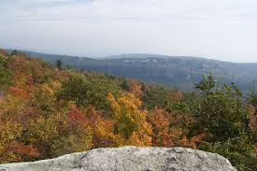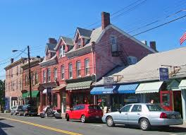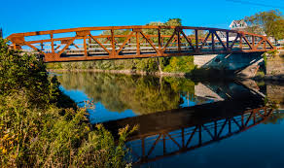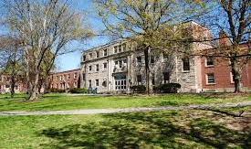
Produced in partnership with ICLEI – Local Governments for Sustainability USA
This project was funded in part by The Climate Smart Community Grant Program, Title 15 of the Environmental Protection Fund through the NYS Department of Environmental Conservation
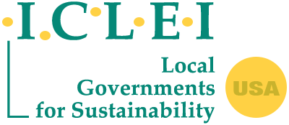
Table of Contents

1 Background and Significance 3
1.1 Climate Smart Communities 3
1.2 New Paltz: A Climate Smart Community 4
1.3 Climate Change Vulnerability Assessment 5
2 Vulnerability Assessment 6
2.1 Methodology 6
NYS Climate Adaptation Framework 6
ICLEI GreenClimateCities 7
Temperate 8
2.2 Results 8
Temperate 8
3 Works Cited 15

Background and Significance
This chapter discusses the context behind the New Paltz Climate Change Vulnerability Assessment report, including the risks posed by climate change, existing state and local initiatives to address climate change, and the value of completing a vulnerability assessment.

Climate Smart Communities
In 2009, New York State launched the Climate Smart Communities (CSC) program, an interagency initiative to encourage local communities to take action towards reducing greenhouse gas emissions and adapting to climate change. The program provides a robust framework for implementing climate-smart actions and issues Climate Smart Community certifications for those who complete a number of those actions. Specifically, a government can become a “Certified Climate Smart Community” if it adopts a resolution containing the 10-point CSC pledge, and completes a set of actions to implement the pledge. The ten required elements of the CSC pledge are as follows:
- Build a climate-smart community by forming a CSC task force with community members, and connecting to larger climate action networks
- Inventory emissions, set goals, and plan for climate action
- Decrease energy use
- Shift to clean, renewable energy
- Use climate-smart materials management
- Implement climate-smart land use
- Enhance community resilience to climate change
- Support a green innovation economy
- Inform and inspire the public
- Engage in an evolving process of climate action
The CSC framework details actions to implement each of the 10 “pledge elements (PEs), as well as for two optional categories: Innovation and Performance. A jurisdiction receives points for each action they complete, and there are three levels of the certification depending on their point total: bronze, silver, and gold.
There are numerous benefits to becoming CSC certified. The certification actions foster energy efficiency and independence, public health, environmental quality, ecological restoration, climate change adaptation, and ultimately the sustainability and resilience of the community. In addition to the advantages of the actions themselves, CSC certified communities receive better scores on certain state grant applications, state-level recognition for their leadership, and access to a network of other certified communities, resources, trainings, tools, and expert guidance (New York State, 2019).

New Paltz: A Climate Smart Community
New Paltz is an economic and cultural hub of 14,003 people whose economy is rooted in both ecotourism and the SUNY New Paltz campus. Climate change activism in New Paltz is a recent phenomenon: The Village of New Paltz formed a Global Warming Task Force in 2004 (since disbanded), and a citizen-based Climate Action Coalition was formed in 2007. Both have often focused on consumer choices such as public recycling bins, promoting cloth shopping bags, repair cafes, home composting, and light bulb replacement. The Climate Action Coalition (CAC) was formed in the wake of the Step It Up campaign event, which showed conspicuous community interest in fighting climate change. Meetings have been held weekly ever since, as CAC has organized highly visible concurrent campaigns and public outreach events.
Most recently, the Town and Village successfully applied for a grant from the New York State Department of Environmental Conservation to fund the process of becoming a certified Climate Smart Community. To help municipalities meet the State’s twin goals of reducing emissions and adapting to unavoidable changes, New York State has created the Climate Smart Communities program under the Department of Environmental Conservation (DEC). In 2016, the Town and Village of New Paltz successfully applied to the Climate Smart Communities grants program and to complete a range of actions:
• Action 6.17: Develop a natural resource inventory,
• Action 7.1: Conduct a vulnerability assessment,
• Action 7.3: Review existing community plans and projects, and
• Action 7.4: Develop climate adaptation strategies.
In addition to these actions, the Town and Village undertake: three Greenhouse Gas Inventories (Town operations, Village operations, and Community), which were completed in 2019, the development of GHG reduction goals, the development of resilience goals, and drafting three Climate Action Plans (again, Town operations, Village operations, and Community). The Town is now focused on completing PE7: Enhance Community Resilience, starting with this Climate Change Vulnerability Assessment. The next step will be developing and implementing a Climate Adaptation Strategy. This Vulnerability Assessment will meet the requirements of New Paltz’s Climate Smart Communities grant in line with the climate planning process articulated by DEC. This report will serve as a starting point for municipal discussion on how Town and Village Board can work alongside the Climate Action Coalition to begin helping New Paltz adapt to climate change.

Climate Change Vulnerability Assessment
Sensitivity: The degree to which a community facet is directly or indirectly impacted by climate variability or change.
Adaptive Capacity: The ability of a community facet to adjust to climate variabilities and extremes to reduce the likelihood of damage, recovery from a destructive event, and leverage opportunities presented by climate change, adverse impacts of climate variability and extremes, adverse impacts of climate variability and extremes.
Vulnerability: The extent to which a community facet is susceptible to, or incapable to manage, adverse impacts of climate variability and extremes; a function of both sensitivity and adaptive capacity.
(Intergovernmental Panel on Climate Change (IPCC), 2014)
A climate change vulnerability assessment identifies community assets, systems, and populations that are particularly sensitive to the impacts of climate change. A vulnerability assessment is a necessary step for developing a climate adaptation strategy, as it characterizes the physical and social elements of a community for which adaptation actions are needed. Generally, vulnerability assessments involve the following steps:
- Identify climatic hazards occurring and likely to occur within the geographic boundary of interest
- Identify community assets, systems, and populations currently and likely to be exposed to the identified climatic hazards
- Assess the sensitivity and adaptive capacity of each exposed asset, system, and population to each applicable hazard
- Use a scoring or prioritization methodology to rank each identified community facet to inform an adaptation strategy.
Several methodologies exist to complete each step. Some methodologies lean more heavily on technical resources and top-town data collection, while others lean more on qualitative input from community members. As there are benefits and drawbacks to every approach, many communities choose a combination of methods that suit their financial, administrative, and political limitations. The methodology chosen by New Paltz is further described in the next chapter.

Vulnerability Assessment

Methodology
This framework behind this vulnerability assessment is consistent with the requirements of the New York State Climate Smart Communities program, as well as ICLEI’s GreenClimateCities framework. The process involved multiple tools and types of data, chosen based on feasibility, comprehensiveness, and replicability for future updates. The context and components of the methodology are further described in the following sections.

NYS Climate Adaptation Framework
The process of climate adaptation assessment is summarized by New York State ClimAID program in the eight steps outlined in Figure 1, beginning with identifying current and future climate hazards that a community faces so that it can then move into cataloguing vulnerabilities to climate change so that opportunities to reduce vulnerability can be prioritized. This Vulnerability Assessment completes Steps 1 through 3 for New Paltz — identifying hazards and prioritizing vulnerabilities — while getting the Town and Village started on tackling Step 4 with a set of recommended adaptation strategies.
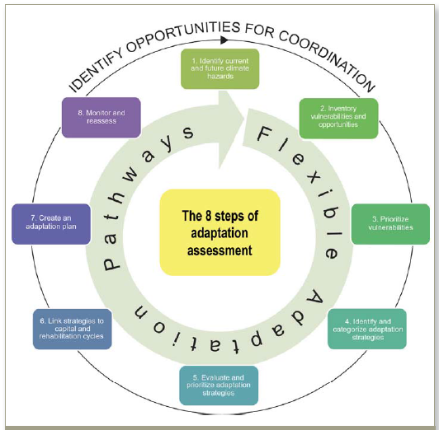
Figure 1: New York State’s ClimAID program outlines an 8-step framework for communities to achieve climate adaptive development.

ICLEI GreenClimateCities
For this assessment, the New York State ClimAID framework is informed by ICLEI’s GreenClimateCities methodology for integrated climate action. Because GreenClimateCities’ steps track closely to the ClimAID framework, the combination is thought to complement each other by integrating New Paltz’s previous greenhouse gas emissions-reduction work (tackling mitigation) with the Vulnerability Assessment addressing climate adaptation (see Figure 2). The additional benefits to incorporating GreenClimateCities are process guidance tailor-made for local governments to “analyze, act, and accelerate” climate action that builds on ClimAID to include measuring, reporting and verification, integrating climate adaptation and climate mitigation activities that New Paltz currently has underway, and including New Paltz in a global network of cities, towns, and regions committed to tackling climate change. Under GreenClimate Cities, New Paltz has already taken the important “Analyze” step to a) Commit and mobilize action (see Section 1.4) and with this Vulnerability Assessment moves the Town and Village into b) Research and assess, and c) Analyze and set baseline, bringing climate adaptation components in line with progress made on mitigation with New Paltz’s greenhouse gas inventory. Armed with the data in the inventory coupled with this report, New Paltz is well positioned to move into the “Act” phases.
Figure 2: ICLEI’s GreenClimateCities framework follows an Analyze-Act-Accelerate pathway for integrated climate action that incorporates GHG emissions reduction, climate adaptation actions, and equitable, inclusive decision-making.

Temperate
TEMPERATE is an online tool created by Azavea, Inc. and ICLEI to assist communities in conducting a climate change vulnerability assessment and developing an adaptation strategy. The tool identified potential climate hazards specifically in New Paltz, based on the geographic regions (latitude 41.74° N, longitude 74.09° W) and findings of the 2014 National Climate Assessment. For projecting how the magnitude and/or frequency of those hazards might change under different emissions scenarios, TEMPERATE uses historical climate data from 1,000 U.S. cities and projects under two popular carbon emission scenarios through the end of the century. To provide the most detail possible, TEMPERATE averages more than 30 climate models provided by a variety of research institutions around the globe.
In addition to identifying hazards, TEMPERATE displays which community systems are likely to be impacted by each hazard. The nexus between climate hazards and community systems is based on the Climate Risk and Adaptation Framework and Taxonomy (CRAFT) developed by the Global Covenant of Mayors for Climate and Energy (GCoM), C40 Cities, and ARUP (GCoM, 2019).

Results

Temperate

Climate Hazards
Reliable climate data can help decision makers plan for impacts. For this reason, both New York State ClimAID and the ICLEI GreenClimateCities frameworks begin with gathering and analyzing data for how precipitation, temperature, and other climate-related elements in New Paltz are anticipated to change over time. This Vulnerability Assessment looked at Temperate tool data from 31 climate models and presented the results at a July 2019 Town and Village Board workshop. The results here reveal these top-level takeaways (see Appendix A) for full results).
Because all the latest evidence points toward the world on track to exceed 3 degrees Celsius of warming (5.4 degrees Fahrenheit), it is important for New Paltz to know what the climate data says for this likely high-emissions scenario. For this reason, the bulk of the climate data relayed here is presented for a warmer, more variable, and more likely New Paltz climate. Table 1 categorizes the most relevant climate indicators for the Town by their amount of change.

Table 1
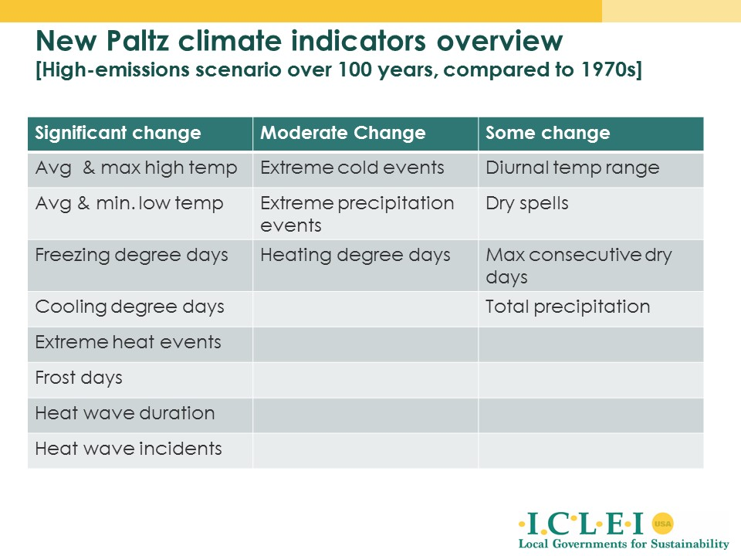
New Paltz is projected to experience 7 times the number of days reaching mid-80s temperature. New Paltz in the 1990s rarely experienced temperatures over upper 80s Fahrenheit. Today, the current maximum average temperature for the Town is 97.2 degrees Fahrenheit. This means that during any given summer, we can expect temperatures to reach the mid-90s, with only some years reaching 100 degrees. However, within a decade, the typical hottest days of summer will become warmer, reaching an average high temperature of 99.6 degrees in 2030. Looking out 30 years to 2050, temperatures are likely to routinely breach 100 degrees and, if climate change goes unchecked, New Paltz can expect highs up to 110 degrees by end of the century. Even if the world is successful in achieving global climate goals, limiting average warming to less than 4 degrees Fahrenheit, the climate of New Paltz is projected to feel comparable to the current conditions for Charleston, S.C., by the end of the Century.
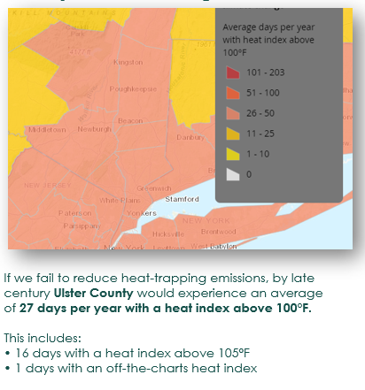
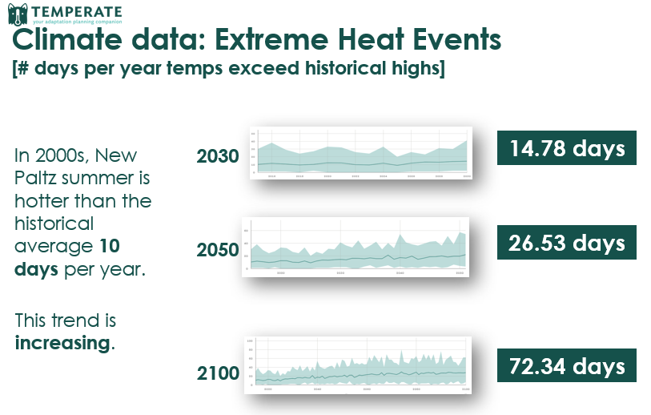
Figure 3

New Paltz is expected to experience 7 times more extreme heat days. During the early 2000s, New Paltz summers have been warmer than the historical average about 10 days per year. This trend is increasing. Because historical average high temperatures for New Paltz have been mid-80s Fahrenheit, In a decade, we can expect about two weeks exceeding mid-80s. Looking out to 30 years, the number of hotter-than-historical days is projected to be 26.5 days. By end of the century, we can expect 72.34 days of hotter-than-normal days. In other words, within 80 years, New Paltz will experience 2.5 months of temperatures hotter than mid-80s most every year.
Within 20 years, New Paltz summer days will routinely begin to reach 100 degrees. Moreover, the majority of these days are likely to exceed 90 degrees and even upwards of 26 days per year exceeding 100 degrees. Often considered a more relevant metric than absolute temperature is heat index, or the perception of heat the average person is thought to experience when temperature is combined with humidity—otherwise thought of as how weather "feels". While Temperate data does not provide heat index values, a June 2019 report by the Union of Concerned Scientists shows that the heat index for Ulster County is likely to top 100 degrees Fahrenheit an average of 27 days per year within 80 years, including 16 days per year with a heat index above 105 degrees Fahrenheit and one “off-the-charts” day each year.
New Paltz is projected to experience 5 times the number of heat waves. A heat wave is considered for this report to occur any time temperatures in New Paltz exceed mid-80s for a five-day period or longer. Recall that mid-80s is considered to the historical high for New Paltz, at least since the 1970s. Today, the Town experiences heat waves an average of three times each year. Going forward, we can expect more and more incidents: five heat waves a decade from now, seven incidents by mid-century, and an average 15 heat waves near every year by the end of the century.
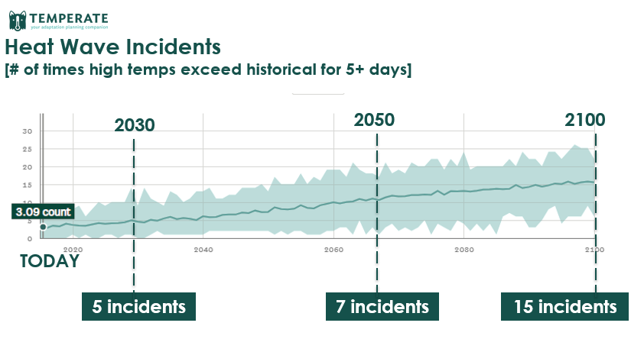
Figure 4

Not only will heat waves be more frequent, but they will last longer, too. Recall that we consider a heat wave to occur anytime temperatures are higher than mid-80s Fahrenheit for five days or longer. During the early 2000s, New Paltz’s temperature exceeded mid-80s no more than seven consecutive days at a time in a typical year. The future is likely to see more years where heat waves last longer than seven days: Within a decade, a typical heat wave is projected to last around 9.5 days, with this trend increasing to an average 12.7 days within 30 years and 28 days by the end of the Century. In other words, within 80 years, when a heat wave comes to New Paltz, it is likely to last upwards of one month at a time without reprieve.
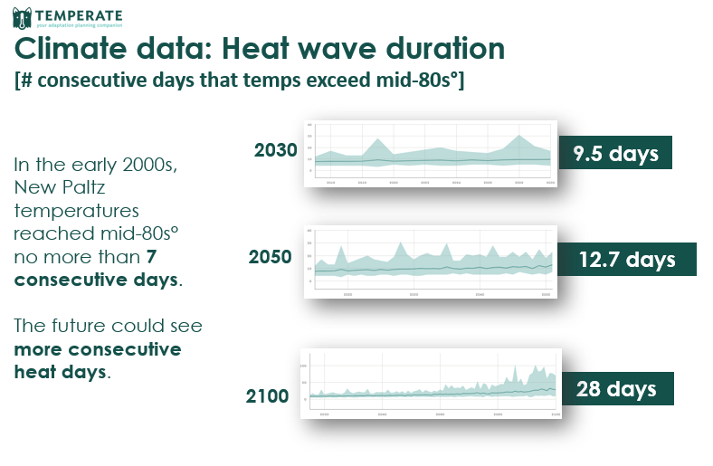
Figure 5

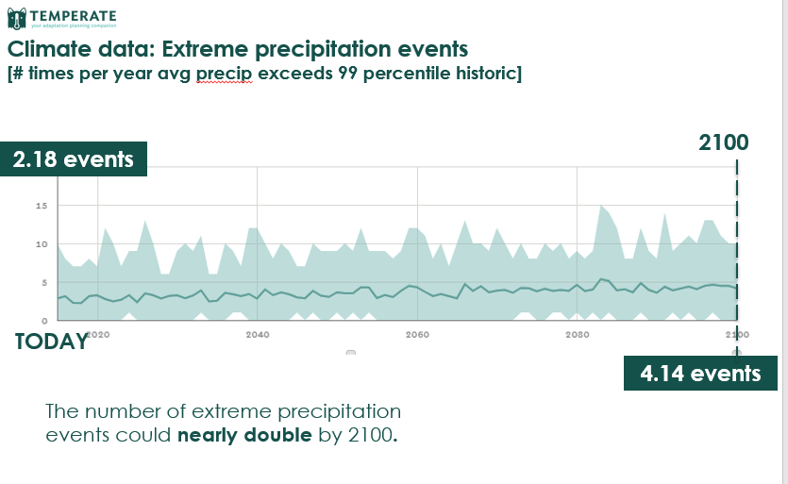
The number of extreme precipitation events are projected to nearly double by 2100. We have seen that New Paltz is projected to experience hotter (and more frequently hot) days over the course of a year. Heat in the atmosphere leads to altered weather patterns and fluctuations in the amount of moisture that is retained in the atmosphere throughout the year. While the total amount of precipitation in New Paltz is anticipated to change only modestly — from an average of 46 inches of precipitation today to an average 52 inches by 2100 — when and how that precipitation falls is likely to change quite a bit. One way is that the number of extreme precipitation events are projected to nearly double within 80 years. This report considers an “extreme precipitation event” to be any time the average precipitation on a given day is higher than the 99th percentile of historical precipitation, in this case looking back to the 1970s. Today, these extreme events of heavy rain or snow occur about twice per year, and that number is anticipated to reach four or more occurrences per year by the end of the century.
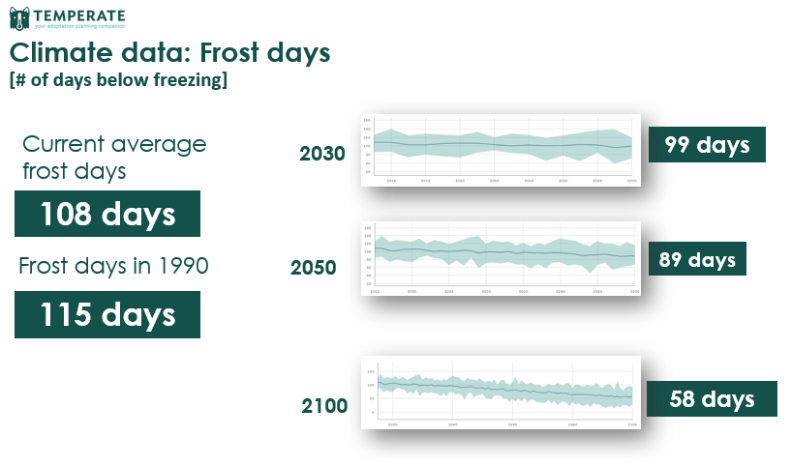
New Paltz freezing days are projected to decrease by half. When temperatures warm, precipitation not only changes in quantity but and timing but also in type. In particular, fewer freezing days indicate more precipitation falling as rain than as snow. New Paltz’s winters already have been warming for some time now. While the average low temperature in the 1990s was -2.5 degrees, the average low today is about 0.25 degree. And this warm-winter trend is projected to accelerate quite fast with a 2030 average low of 3.5 degrees moving up to an average 14 degrees within 80 years. Because snowy winters depend on the number of frost days, or days below freezing, we can anticipate fewer snow days: Current frost days occur an average 108 days each year, reducing over time to an average just 58 frost days in 80 years.
New Paltz anticipates a precipitation shift from snow to rain. While Temperate outputs are able to project for precipitation changes, it will not speak to type of precipitation and changes throughout the year, such as snow versus rain. For trends in snowpack and snowfall, New Paltz Vulnerability Assessment relies on Chapter 18 of the National Climate Assessment, which details impacts to snow for the Northeast region:
As Northeast winters warm, scenarios project a combination of less early winter snowfall and earlier snowmelt, leading to a shorter snow season. The proportion of winter precipitation falling as rain has already increased and will likely continue to do so in response to a northward shift in the snow–rain transition zone projected under both lower and higher scenarios (RCP4.5 and RCP8.5). The shift in precipitation type and fewer days below freezing are expected to result in fewer days with snow on the ground; decreased snow depth, water equivalent, and extent; an earlier snowmelt; and less lake ice. Warming during the winter–spring transition has already led to earlier snowmelt-related runoff in areas of the Northeast with substantial snowpack.
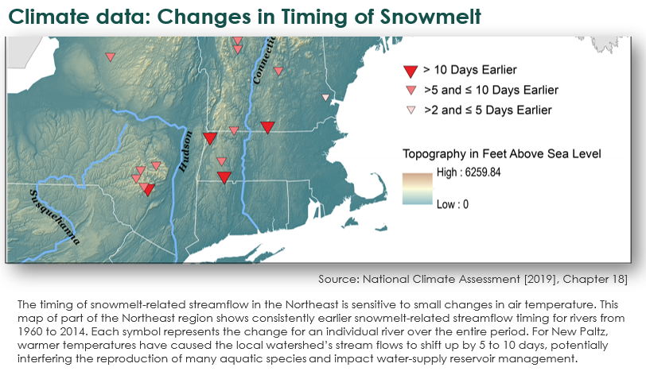

Works Cited
GCoM. (2019). Resources for Cities. Retrieved from Global Covenant of Mayors for Climate and Energy: https://www.globalcovenantofmayors.org/our-initiatives/data4cities/resources/
Intergovernmental Panel on Climate Change (IPCC). (2014). Summary for Policymakers. In: Climate Change 2014: Impacts, Adaptation, and Vulnerability. Cambridge, United Kingdom and New York, NY, USA: Cambridge University Press.
New York State. (2019). Climate Smart Communities. Retrieved from New York State: https://climatesmart.ny.gov/about/

http://www.baylocalize.org/files/Community_Resilience_Toolkit_v1.0.pdf

